Help Make the Bell Ring Again!

The Elberon Memorial Church’s 140-year-old bell needs repair, and we need your help to make it ring again. If you’d like to contribute, please send your donations to: Elberon Memorial Church with a note saying,

“Make the Bell Ring Again.”

I appreciate your support in preserving this cherished piece of our history!

Elberon Memorial Church. 70 Park Avenue. Elberon, NJ 07740
#ElberonMemorialChurch
#MakeTheBellRingAgain

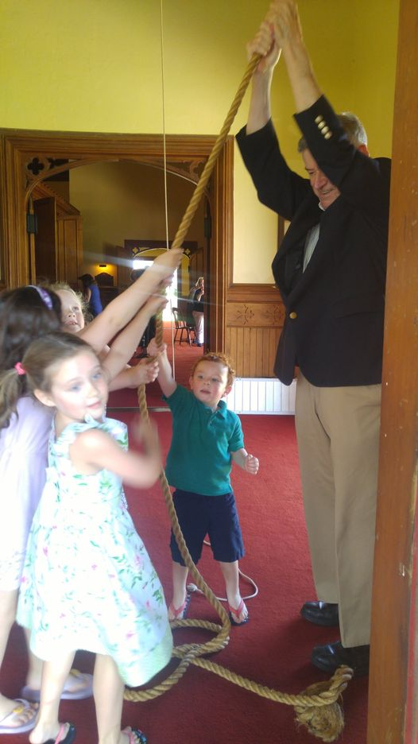
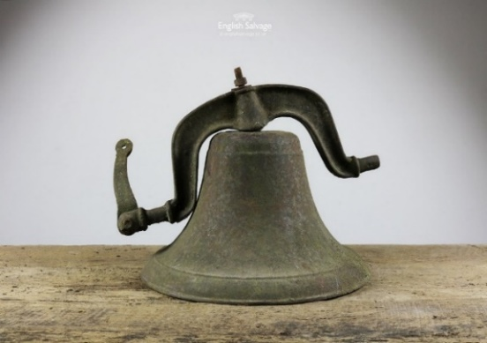
Howard Woolley 732-222-0001
hwool@comcast.net

