Help Make the Bell Ring Again!

The Elberon Memorial Church’s 138-year-old bell needs repair, and we need your help to make it ring again. If you’d like to contribute, please send your donations to: Elberon Memorial Church with a note saying,

“Make the Bell Ring Again.”

Thank you for your support in preserving this cherished piece of our history!

Elberon Memorial Church. 70 Park Avenue. Elberon, NJ 07740
#ElberonMemorialChurch
#MakeTheBellRingAgain

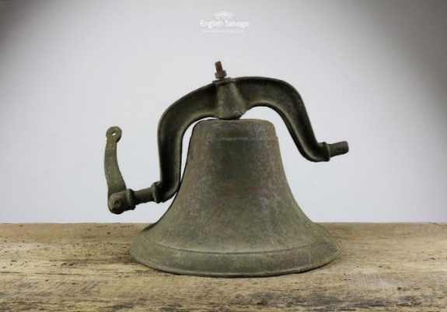
Sharon Lees @ 732-687-8430
Sharonlees1@verizon.net

